**Delta File Format**

Create a Pipeline

Got to synapse –> Integrate-> Click in + to create a pipeline, then drag and drop dataflow activity. Then click on dataflow debug

Then click on add source and get source data from ADLS.

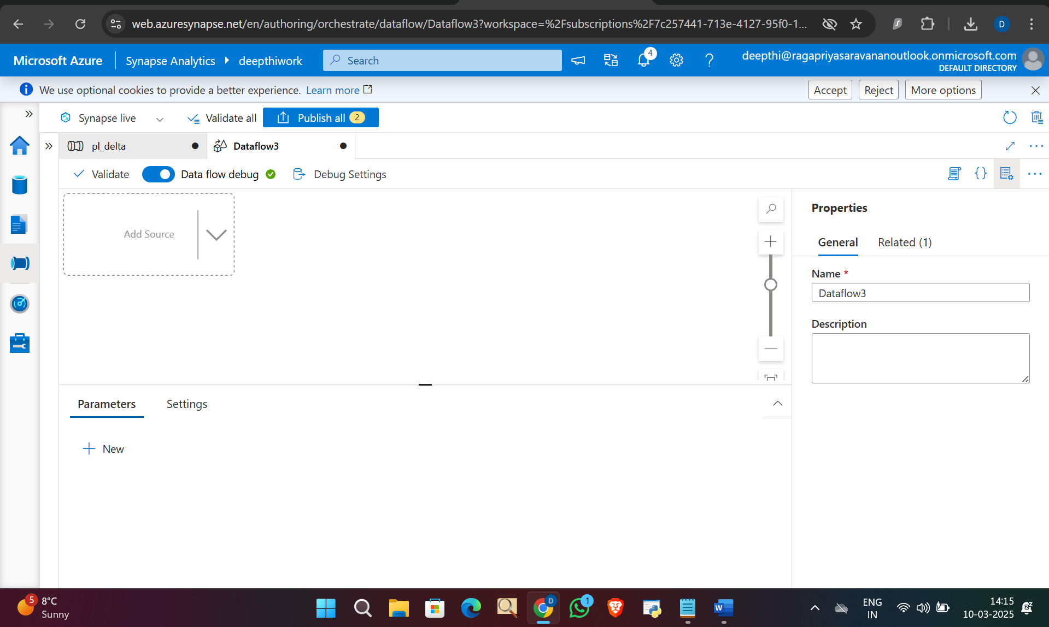

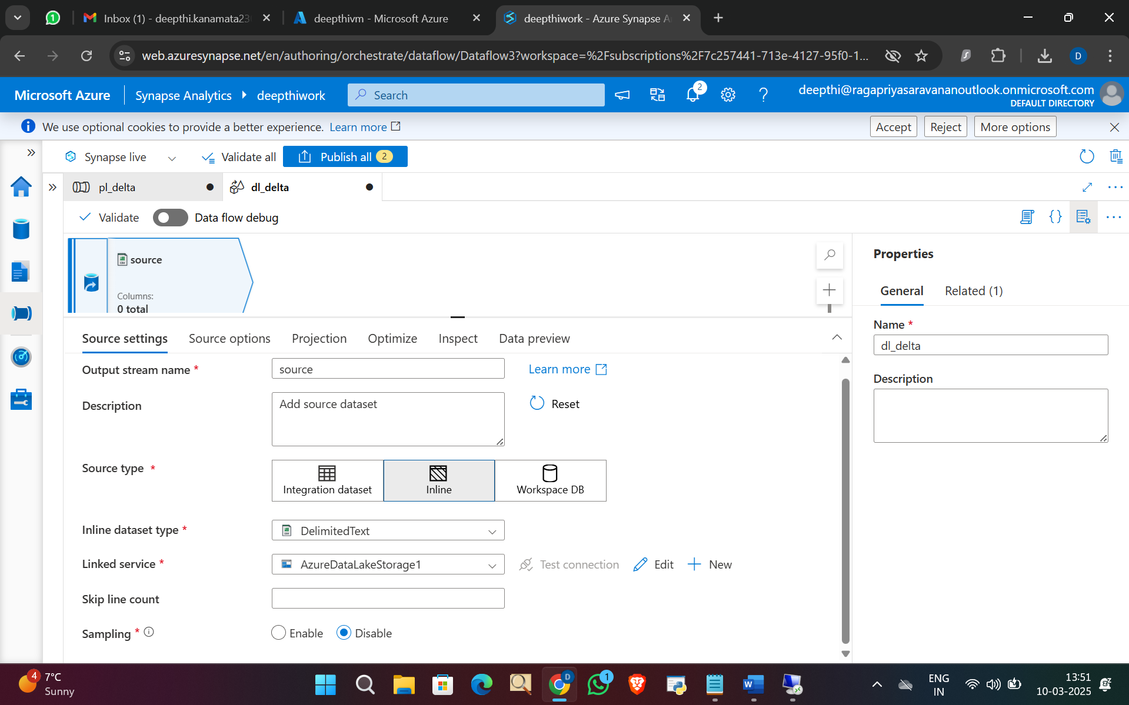

Go to source options and give the file path.

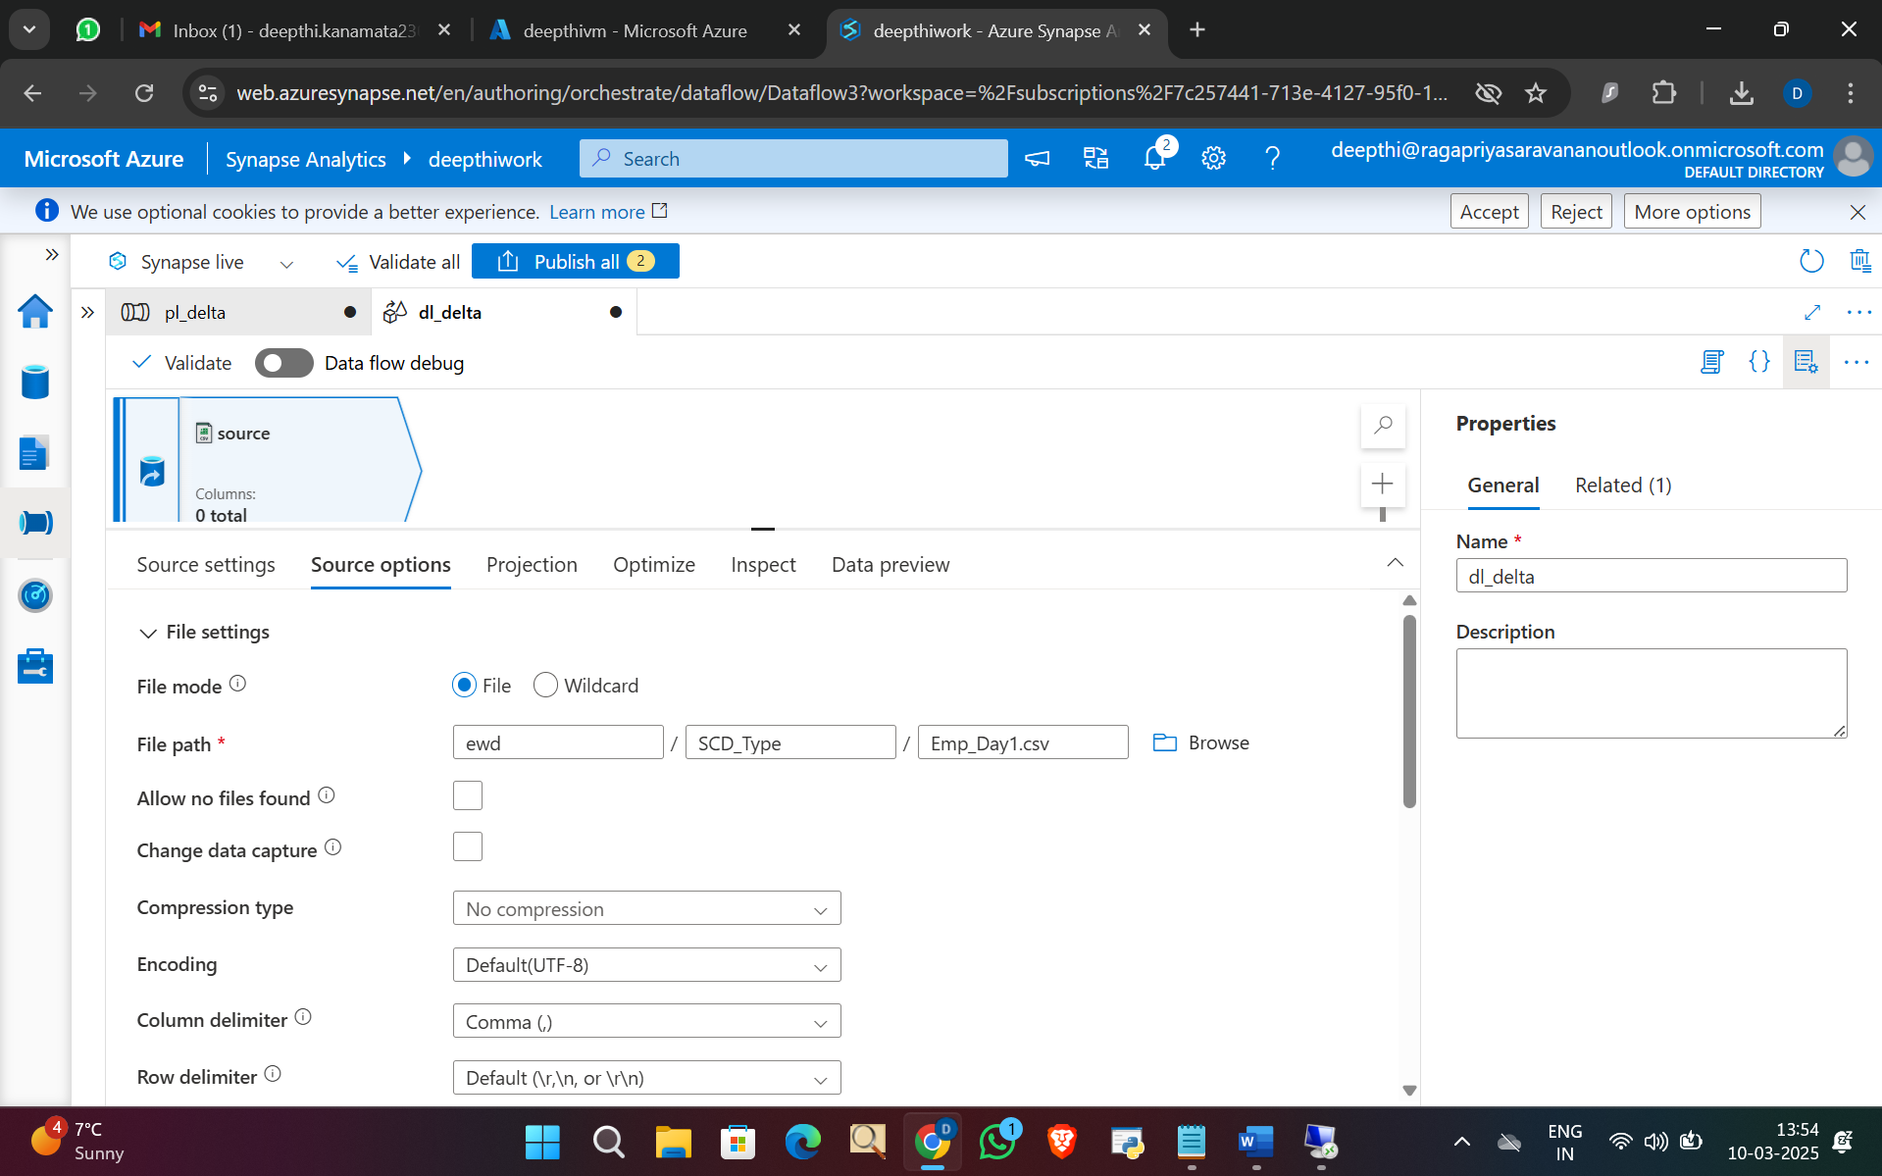

Go to projection and import schema

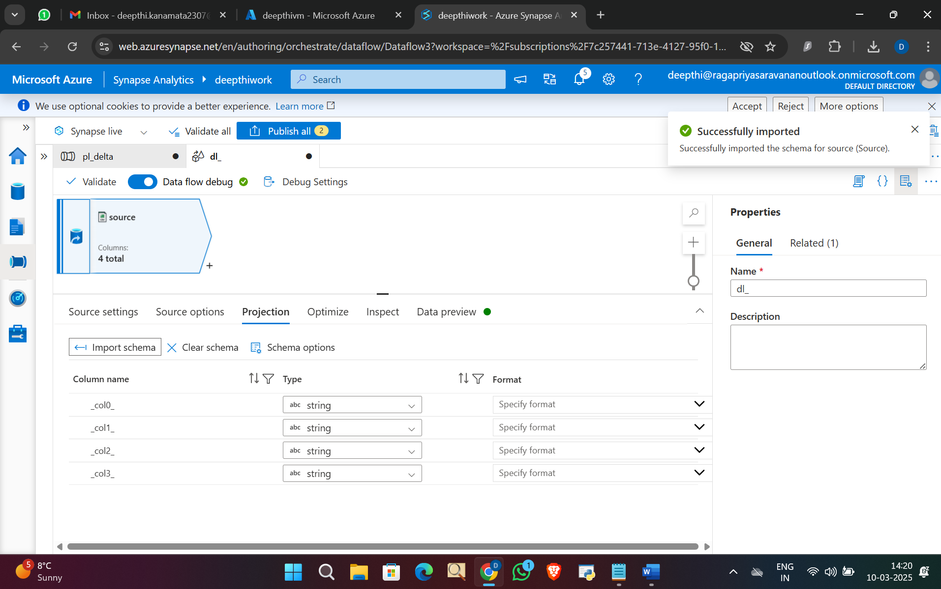

Go to data preview and click refresh.

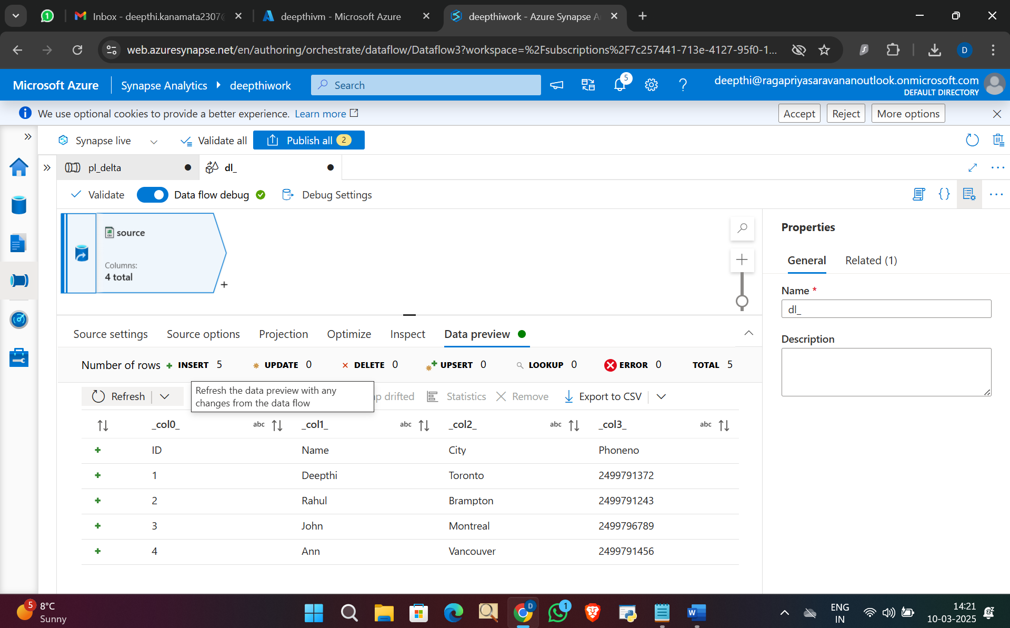

Then add derived column to add Hash column then give this hash function expression and click on save and finish.

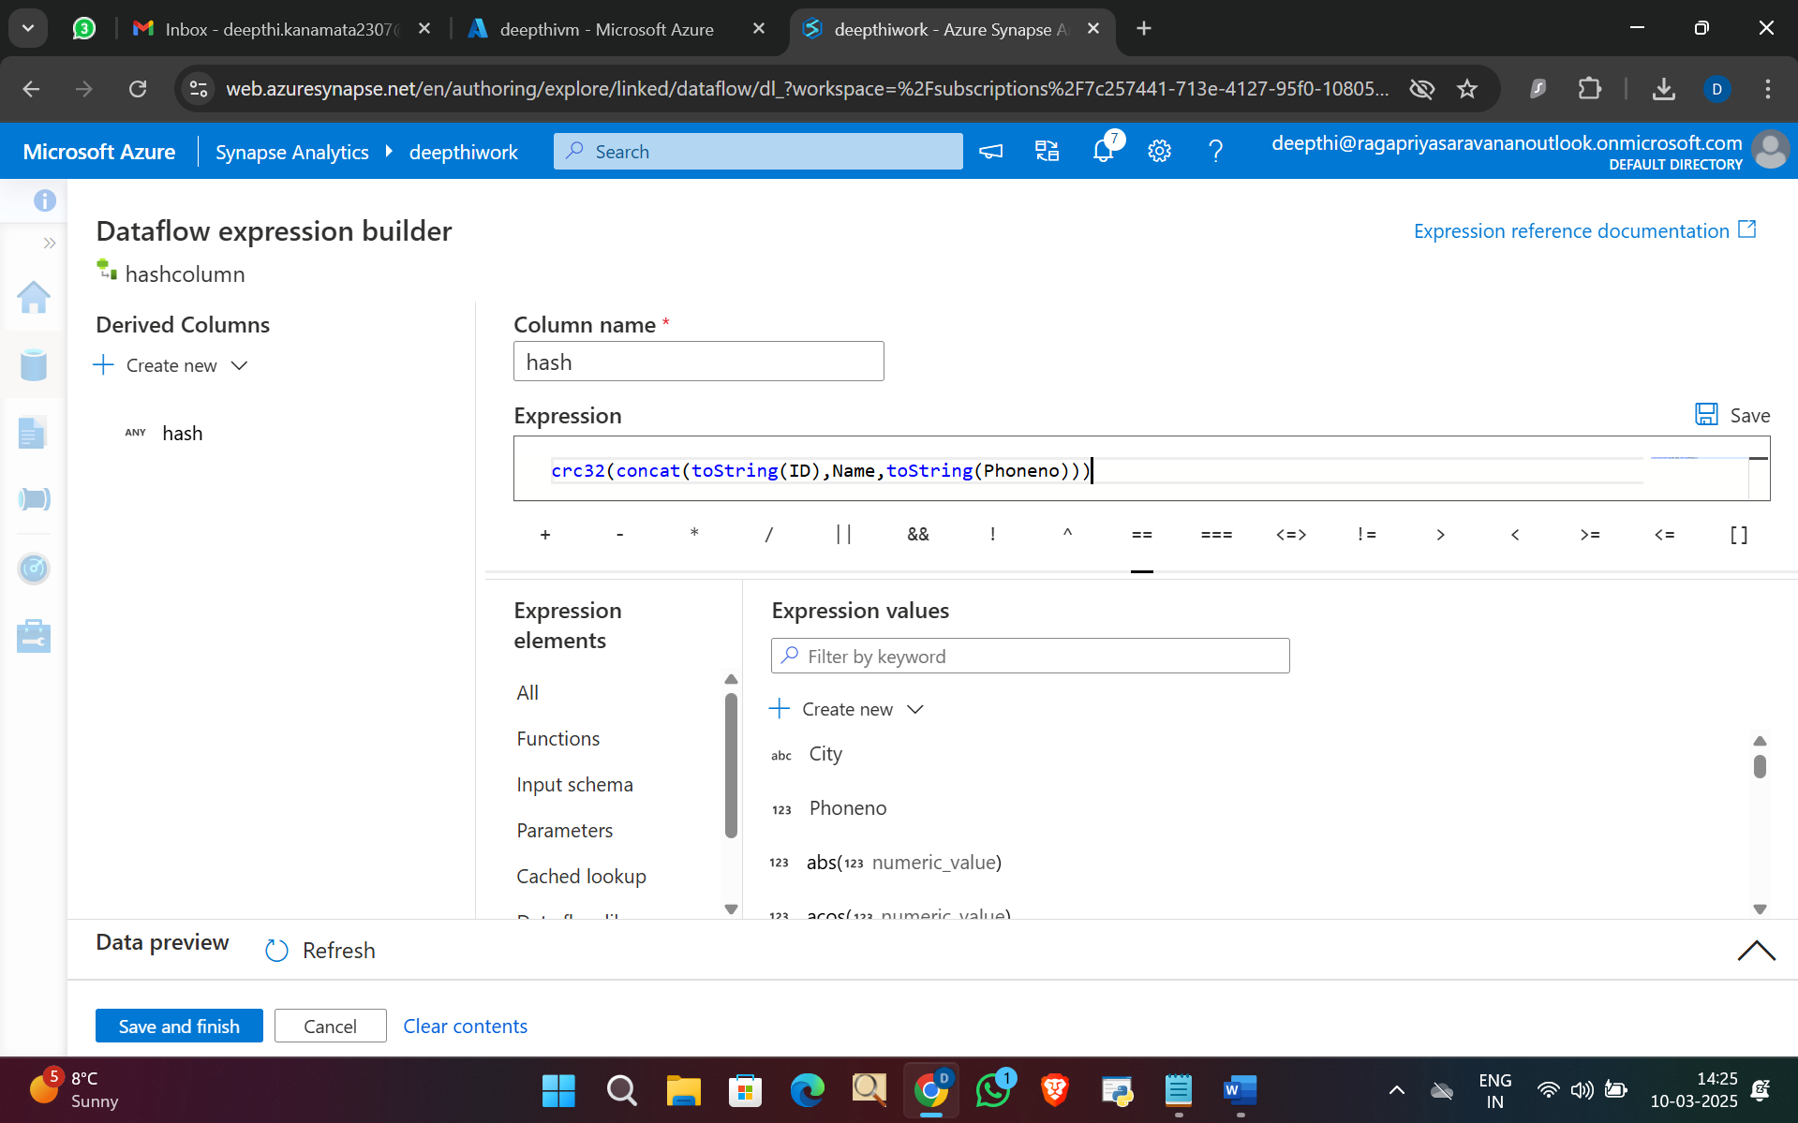

Data preview and see hash column is added.

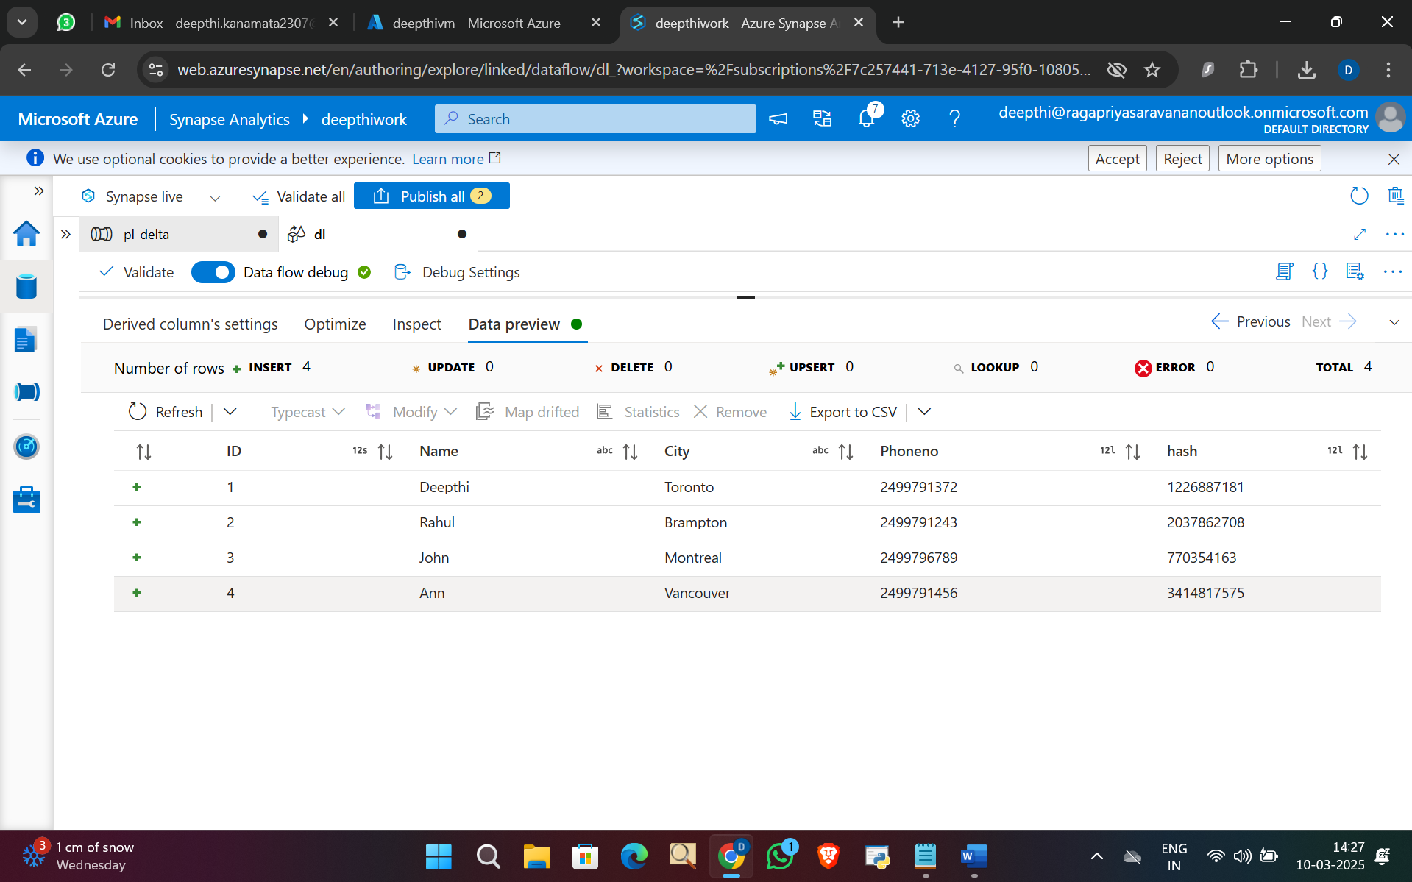

Add alter row activity to add condition for Upsert which can do action for updating and insertion.

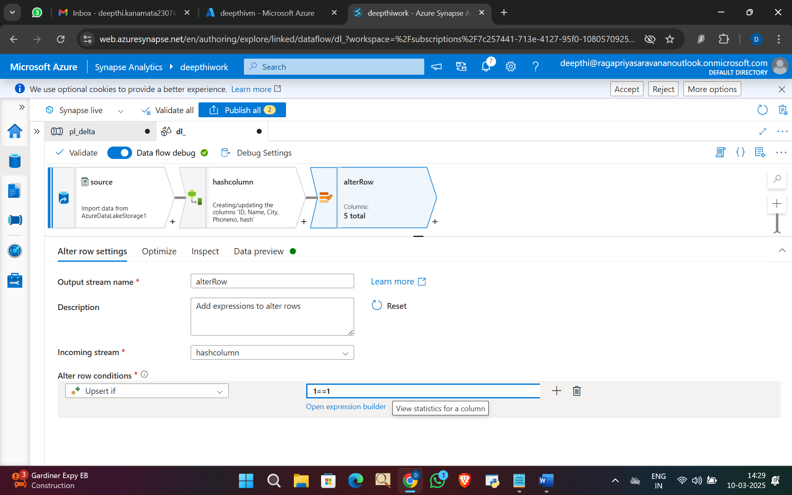

Add sink activity and give dataset as delimited text and linked service to ADLS.

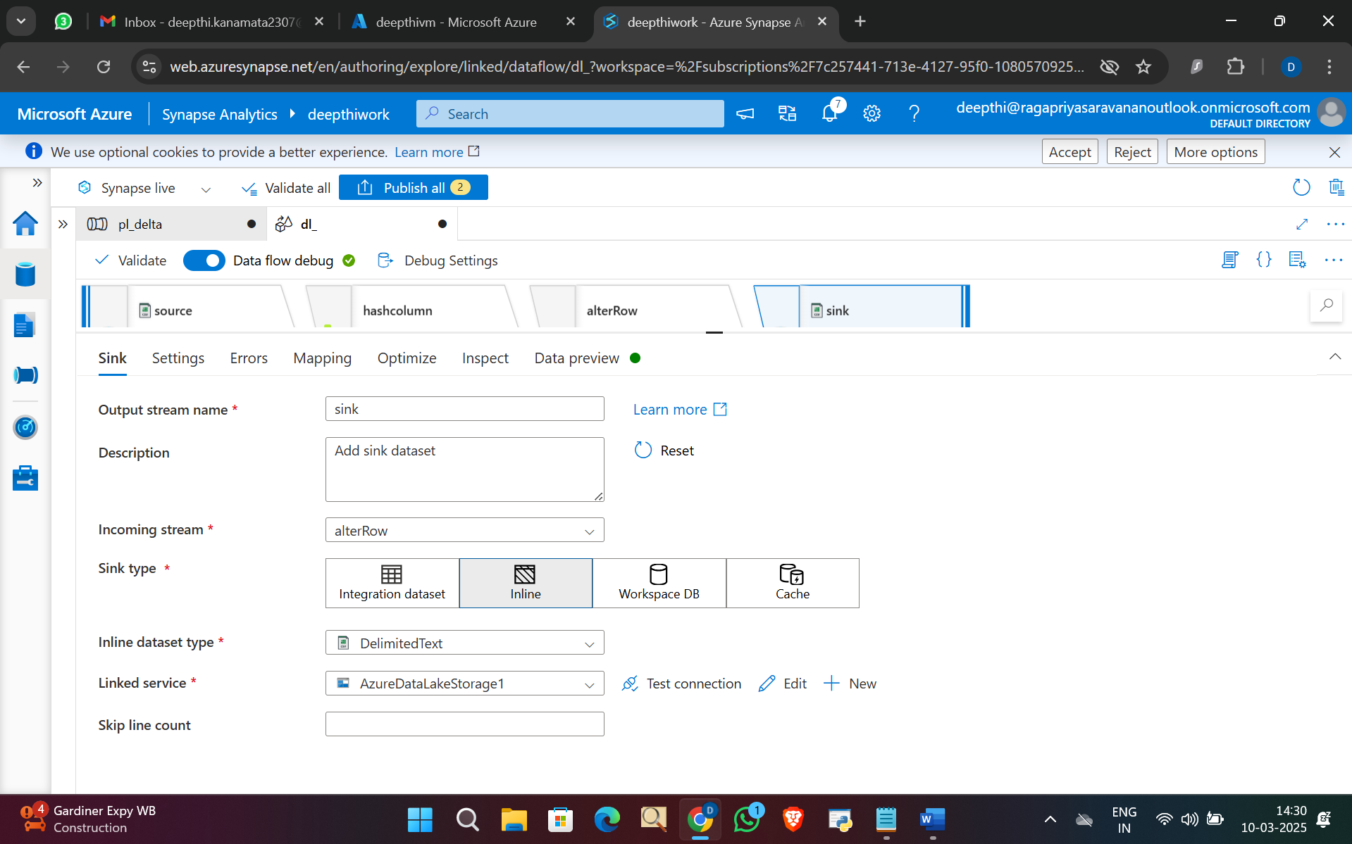

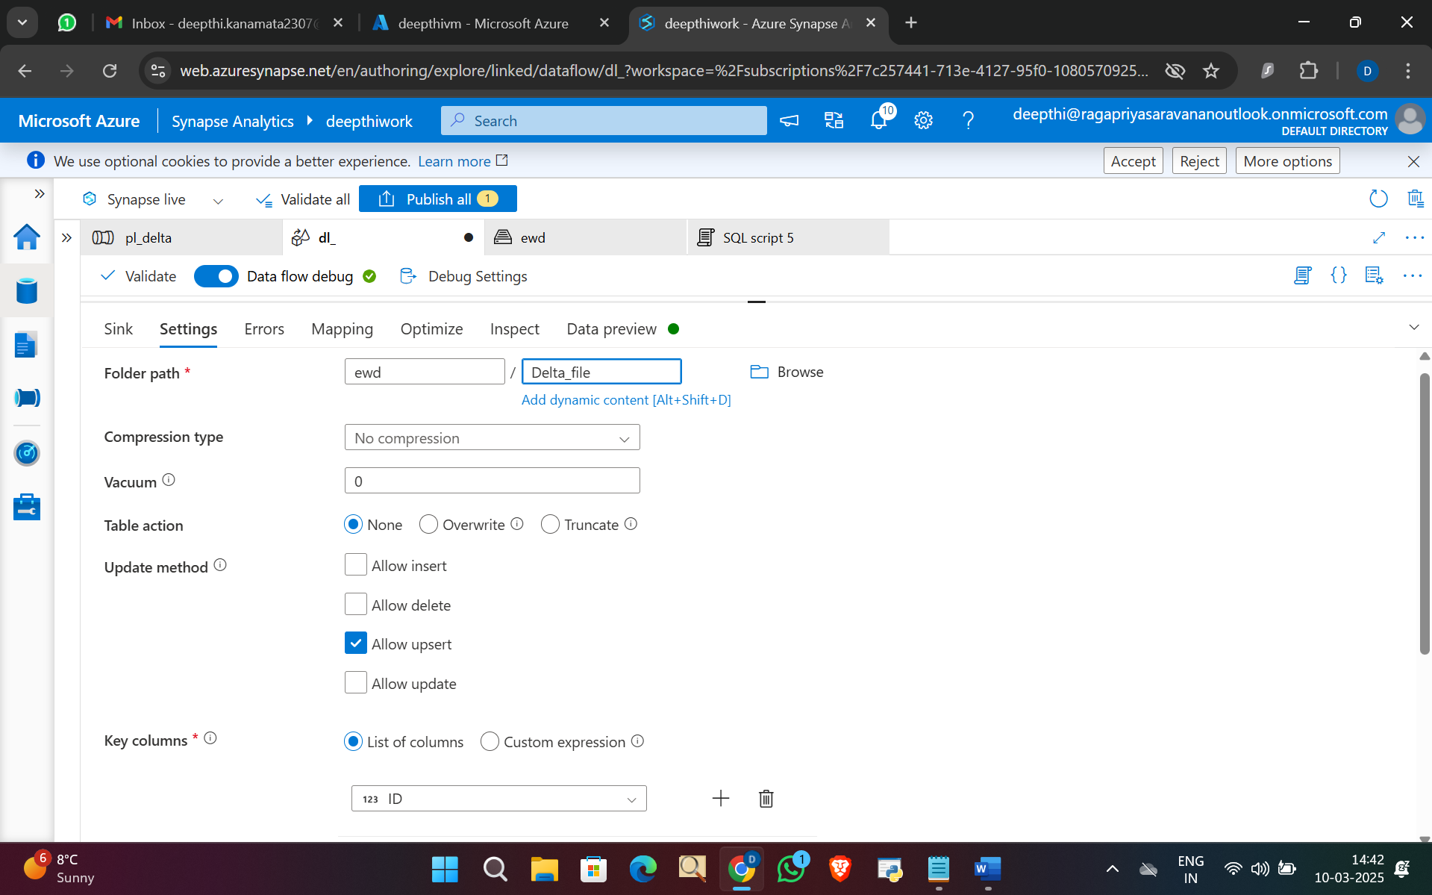

Data preview

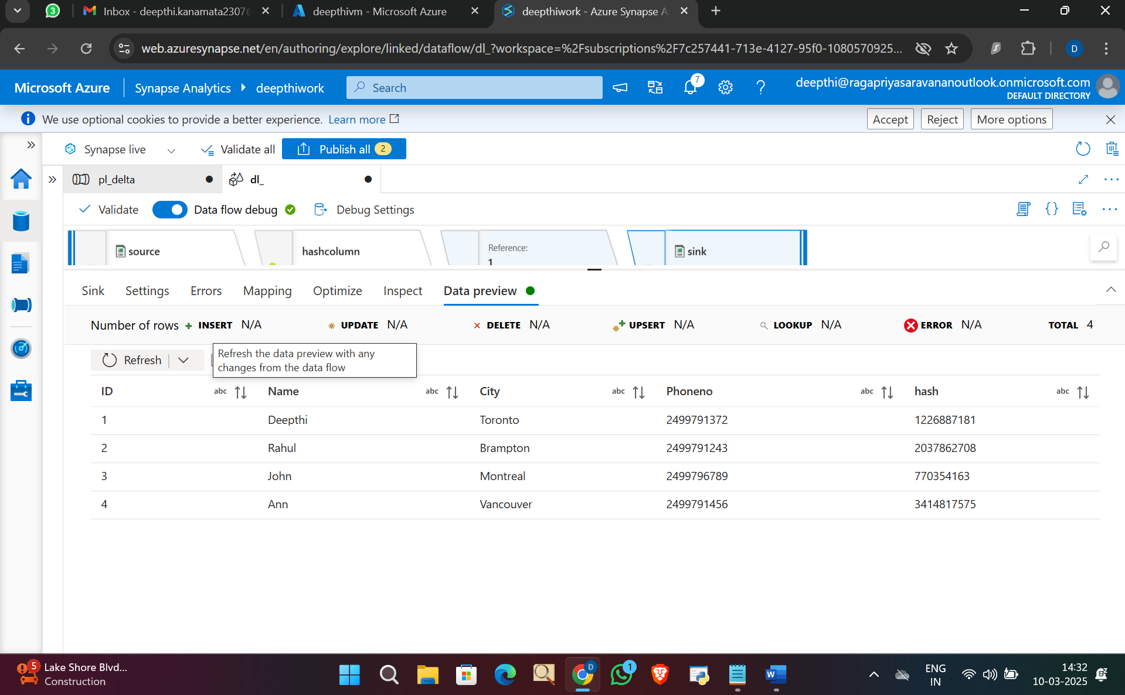

Publish pipeline and run

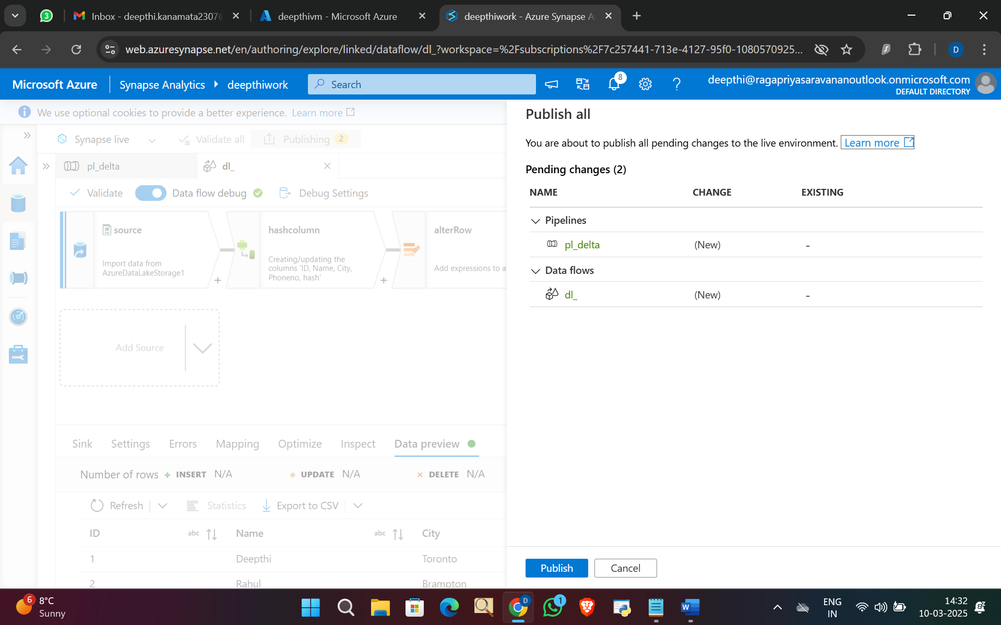

Pipeline ran successfully

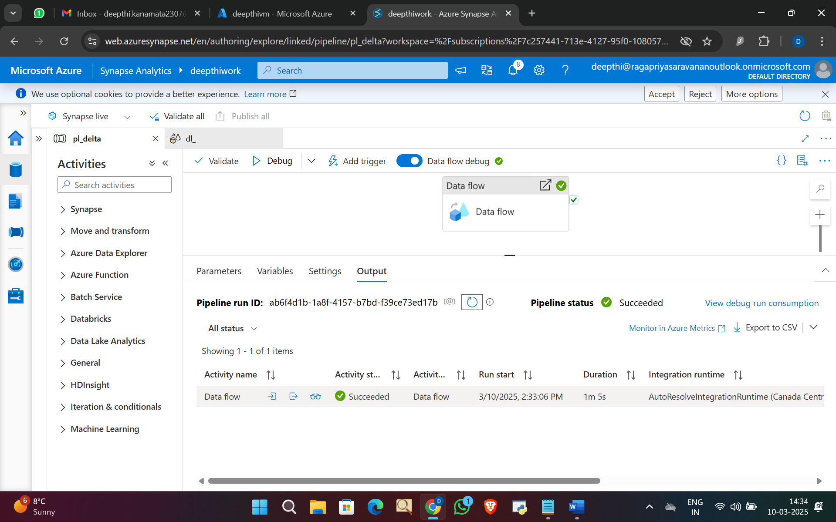

Go to Data tab and click on ADLS storage and container and go to the folder and right click and select new sql query

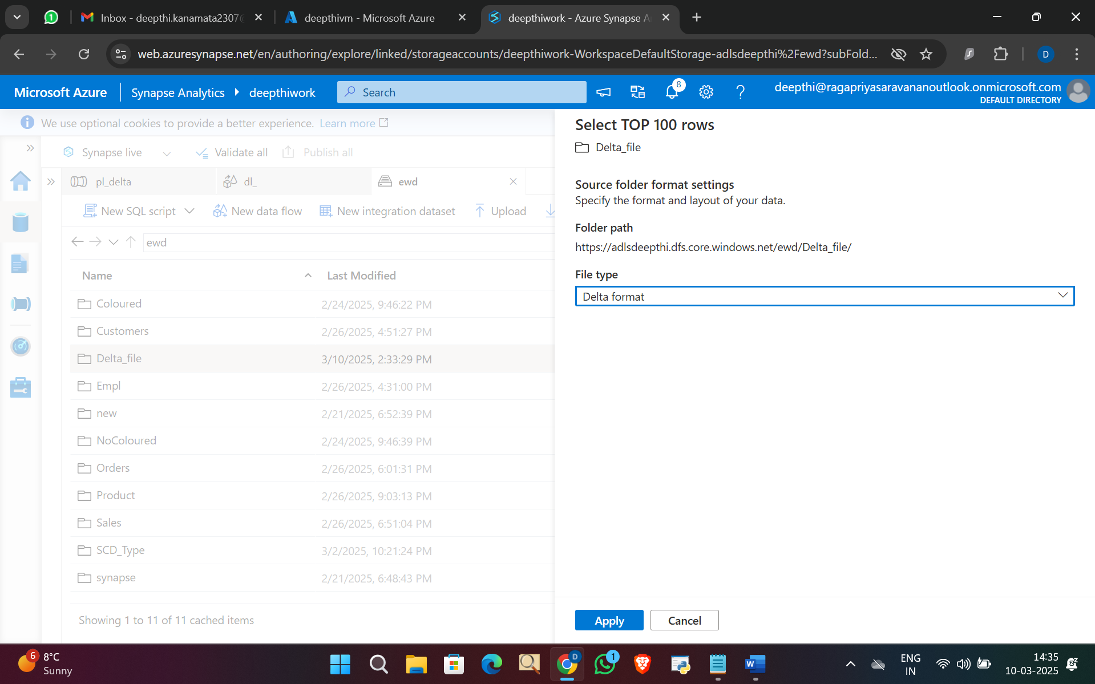

Run the query

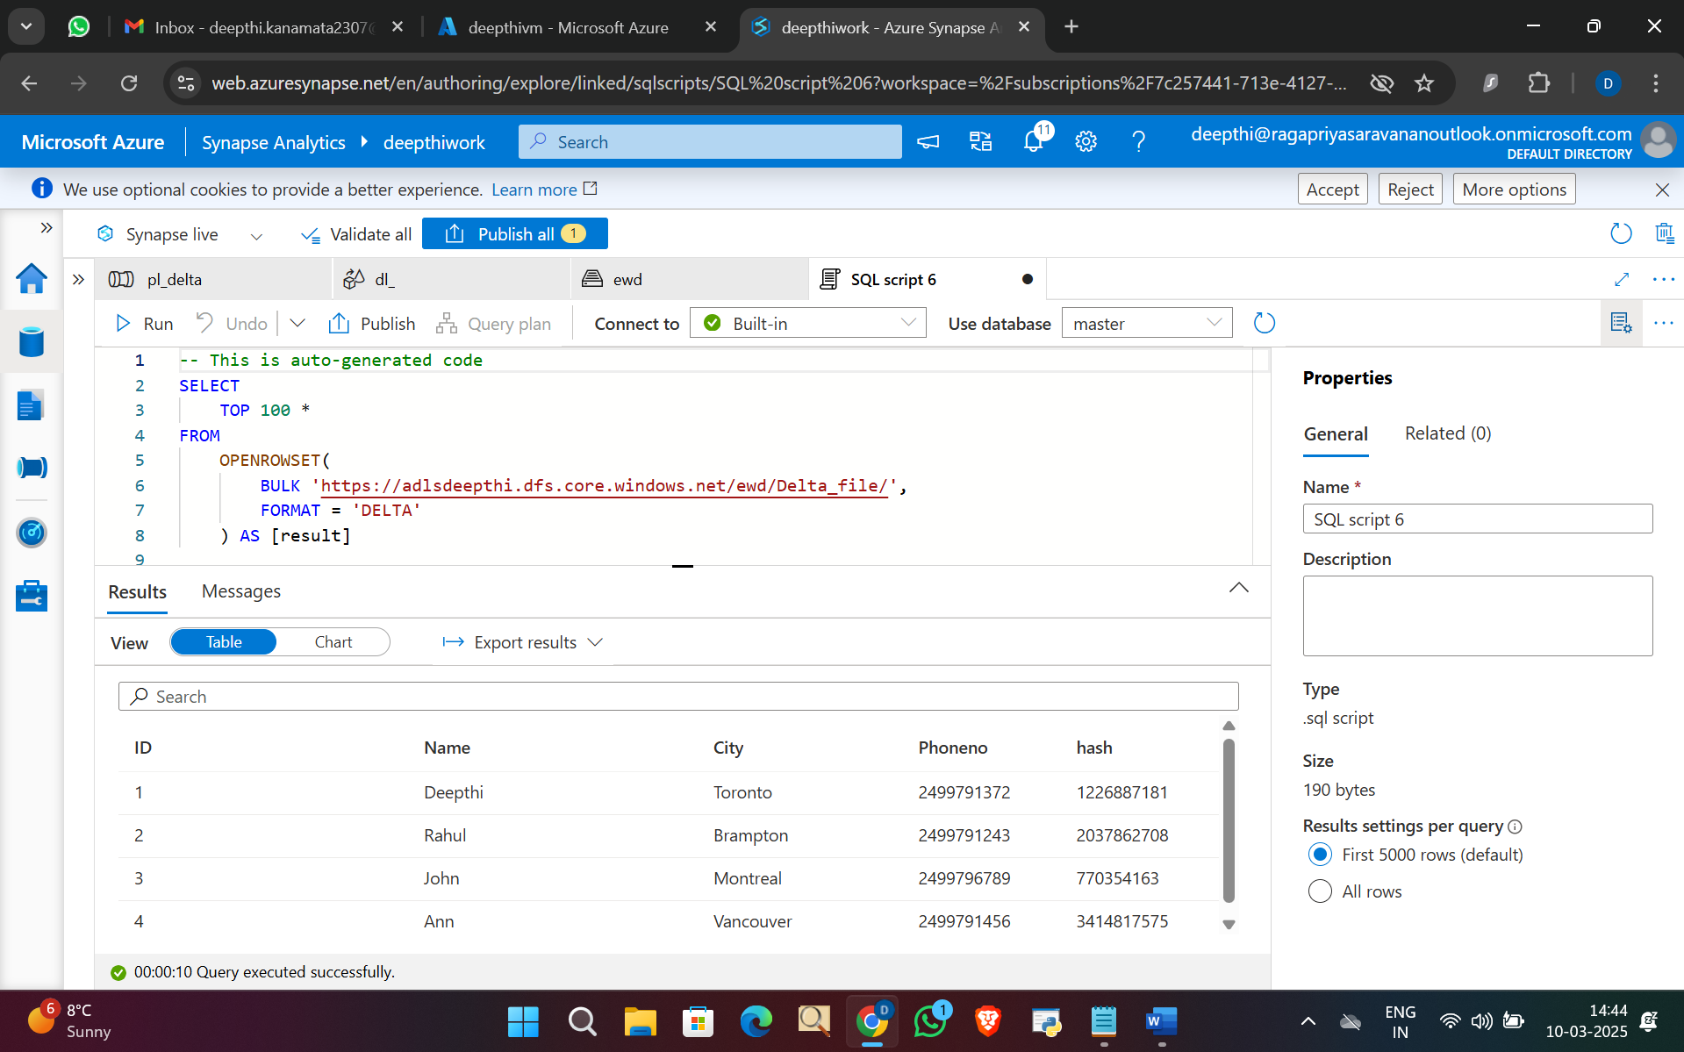

Now changing file from Day 1 to Day 2

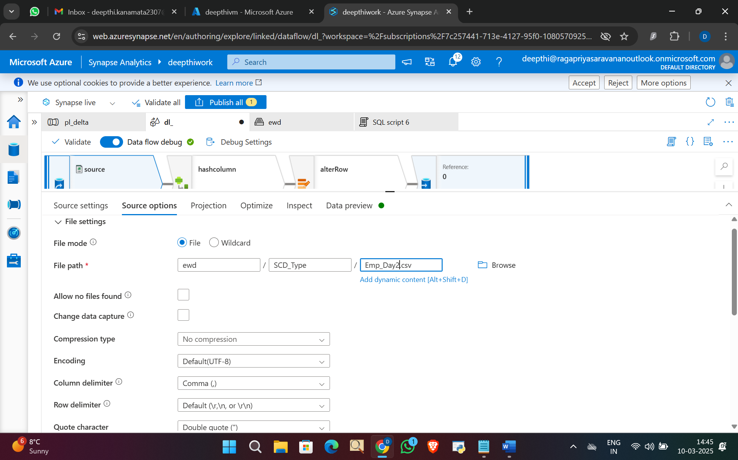

Publish and run the pipeline.

Pipeline ran successfully

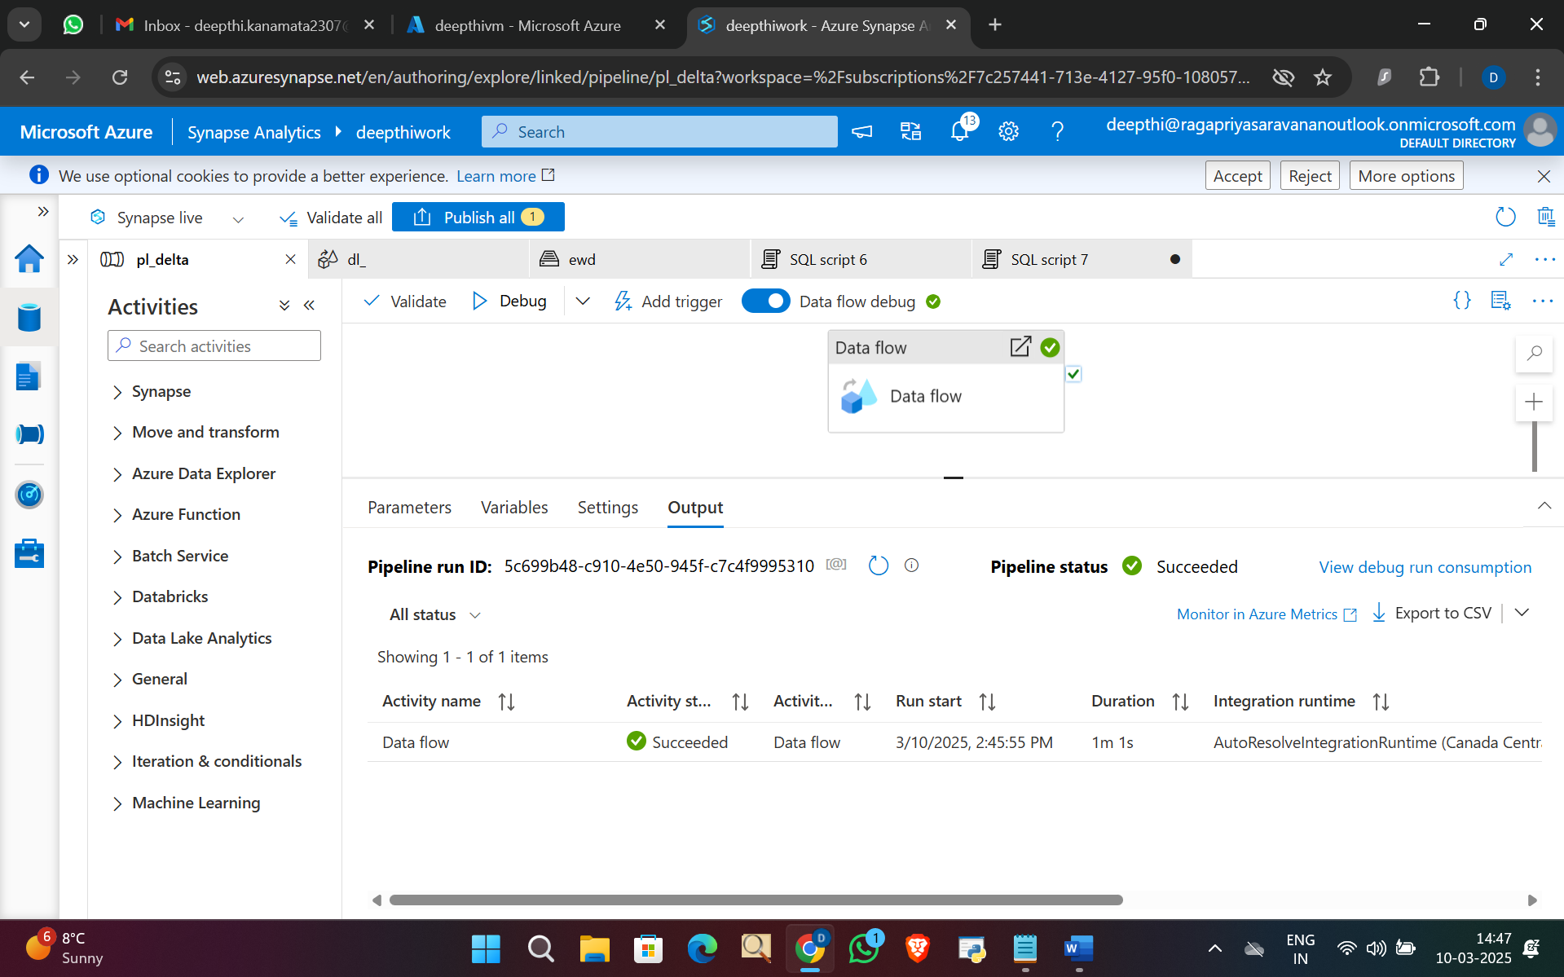

Now to go ADLS and right click on folder to get a query to run

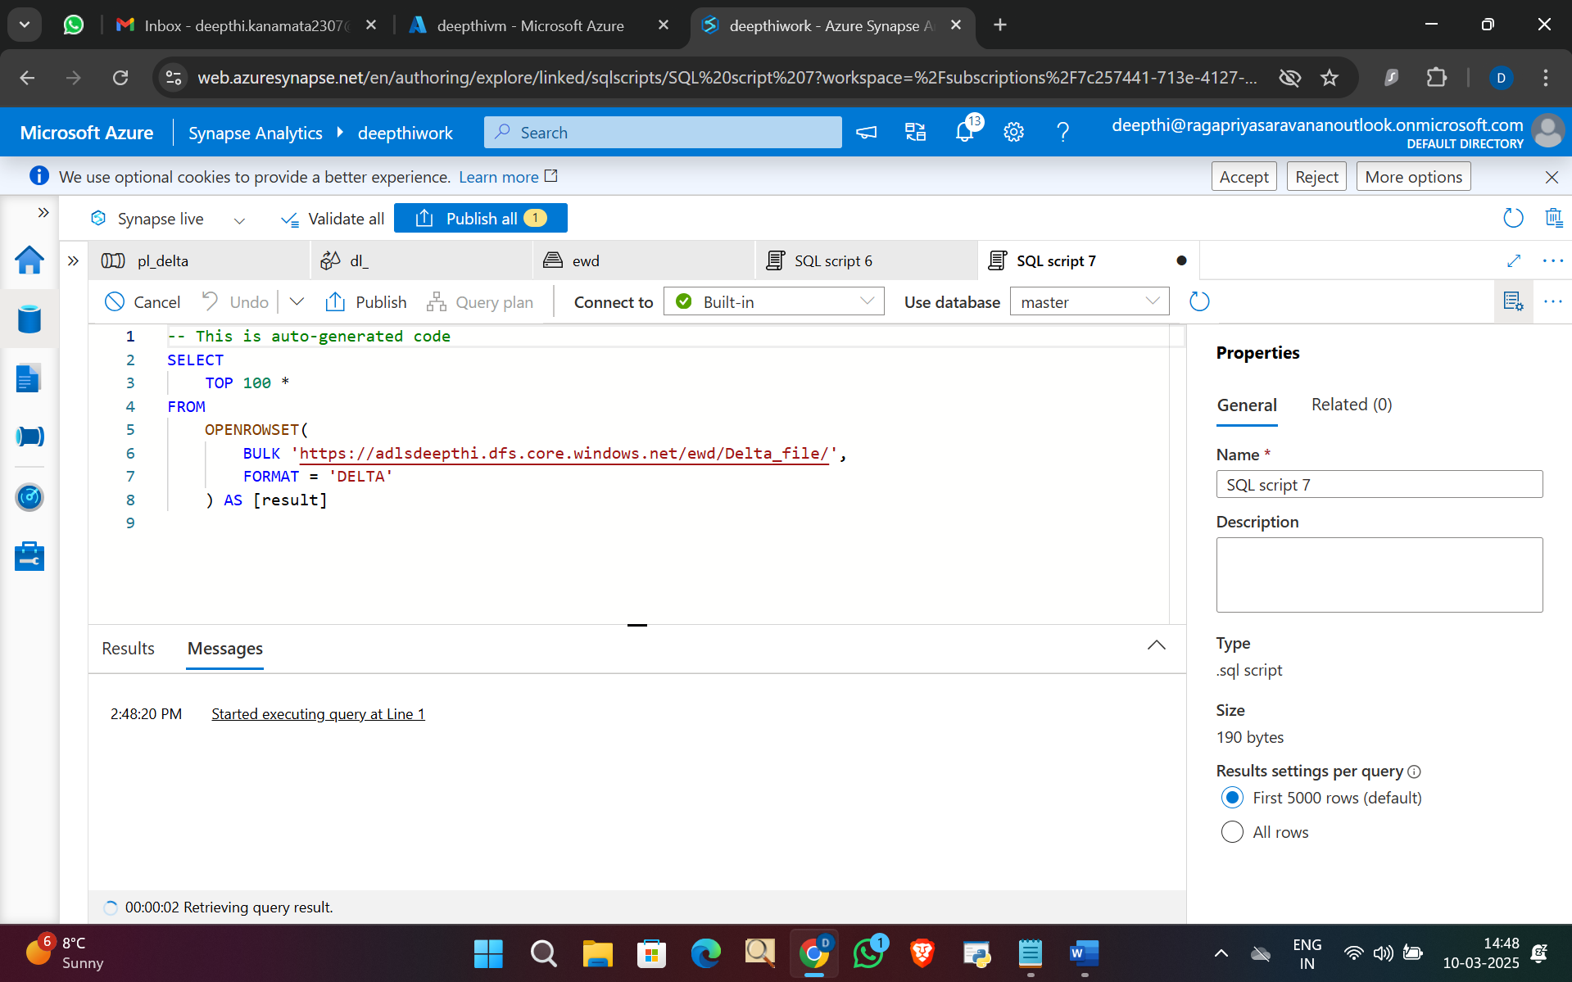

Query ran successfully and ID 1 record is updated and ID 7 is inserted.

